Pixalink Issues Continued

1. When you play a video, then exit off of it, it continues to play in the background and it should not.
2. You did make the websites clickable, but what we meant was that the websites should be usable within our website, rather than opening in another tab, just like the website “StumbleUpon”… see here 🡪 <http://www.stumbleupon.com/su/1TrMUJ/OJSxnNaN:Iy_jOJZR/greenglobaltravel.com/2015/05/17/10-best-places-to-scuba-dive-for-your-world-travel-bucket-list>

//23-05-2015: We have implemented the website link open functionality like above comment. See the below screenshots

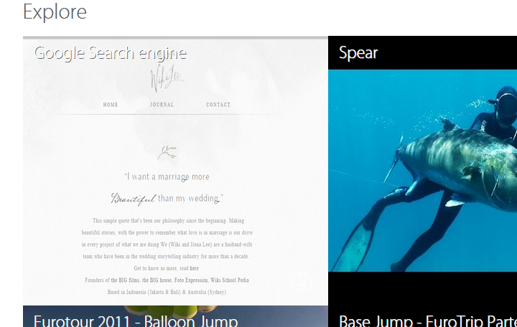

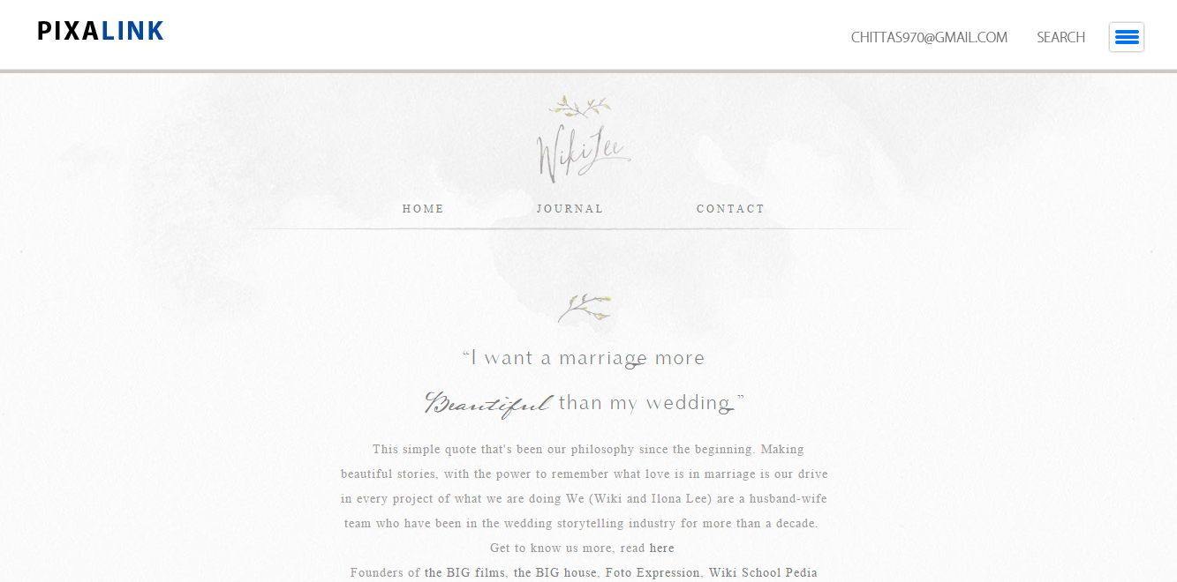

When posting a video, you should not need to put a title or description, as it comes with the video, as you can see in the below image.

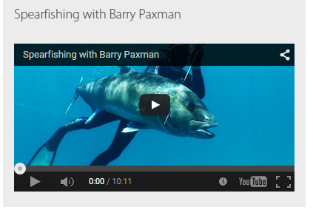

When using the below feature, videos and the websites don’t work, only images. They need to both work through this.



//23-05-2015: We have fixed the video invisible issue from home page

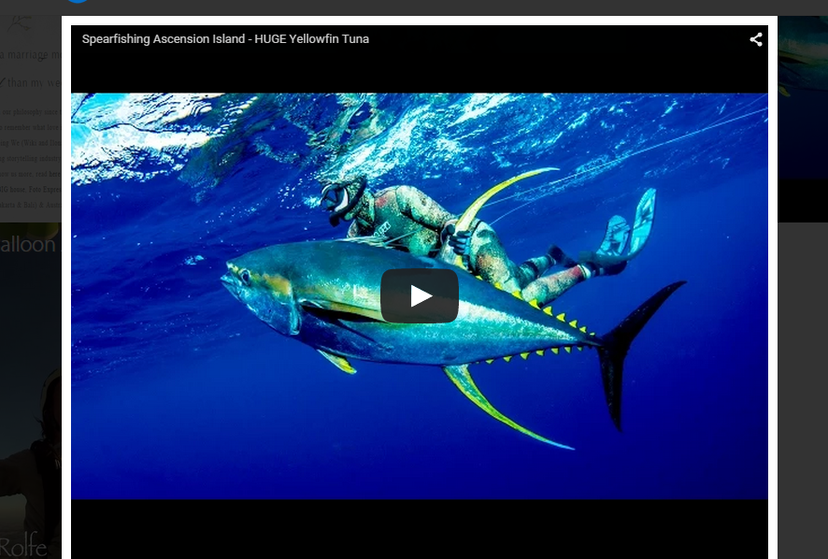

We need to get rid of the Designs below as well, there is no use for them.



The below image is of when there is only 3 links on the website. The flow through seems distorted. It should not be. Also, it has every link on the website, this is supposed to be a popular board, so only links which are liked.

